|  |  |  |
| --- | --- | --- |
| **Guide Name** | | **Panel Head** |
|  | Dr.Nivedhitha M | Dr. Thenmalar S |
|  |  |  |
|  | **Faculty Advisor** | **Project Domain** |
|  | Dr. Sivamohan S | SDG 4 : Quality Education |
| M |  |  |
|  | **Student(s) Details: Name** | **Passport size photo(s)** |
|  | 1. AUGNIK BANERJEE 2. ANIKET SINGH |  |
|  |  |  |

Registration Number(s)

1. RA2211028010006

2. RA2211028010014

**Email ID(s)&Mobile Number(s)**

|  |  |
| --- | --- |
| 1: [ab0710@srmist.edu.in](mailto:ab0710@srmist.edu.in) - 9389838836 | 2: [as0872@srmist.edu.in](mailto:as0872@srmist.edu.in) - 7088678264 |

**Abstract Architecture Diagram**

The increasing complexity of molecular visualization and generation necessitates advanced computational tools for researchers and developers. This study presents a cloud-based **Molecular Visualization & Generation Platform** that leverages **Next.js, Node.js, and MongoDB** for seamless user interaction, real-time collaboration, and secure data storage. The platform integrates **RDKit.js for 2D/3D molecular visualization, NVIDIA AI for molecule generation, and PubChem API for molecular data retrieval**. The methodology encompasses **data ingestion, molecule representation, feature extraction, model training, and visualization**. This platform enables researchers to design and analyze molecules efficiently, fostering advancements in computational chemistry and drug discovery.

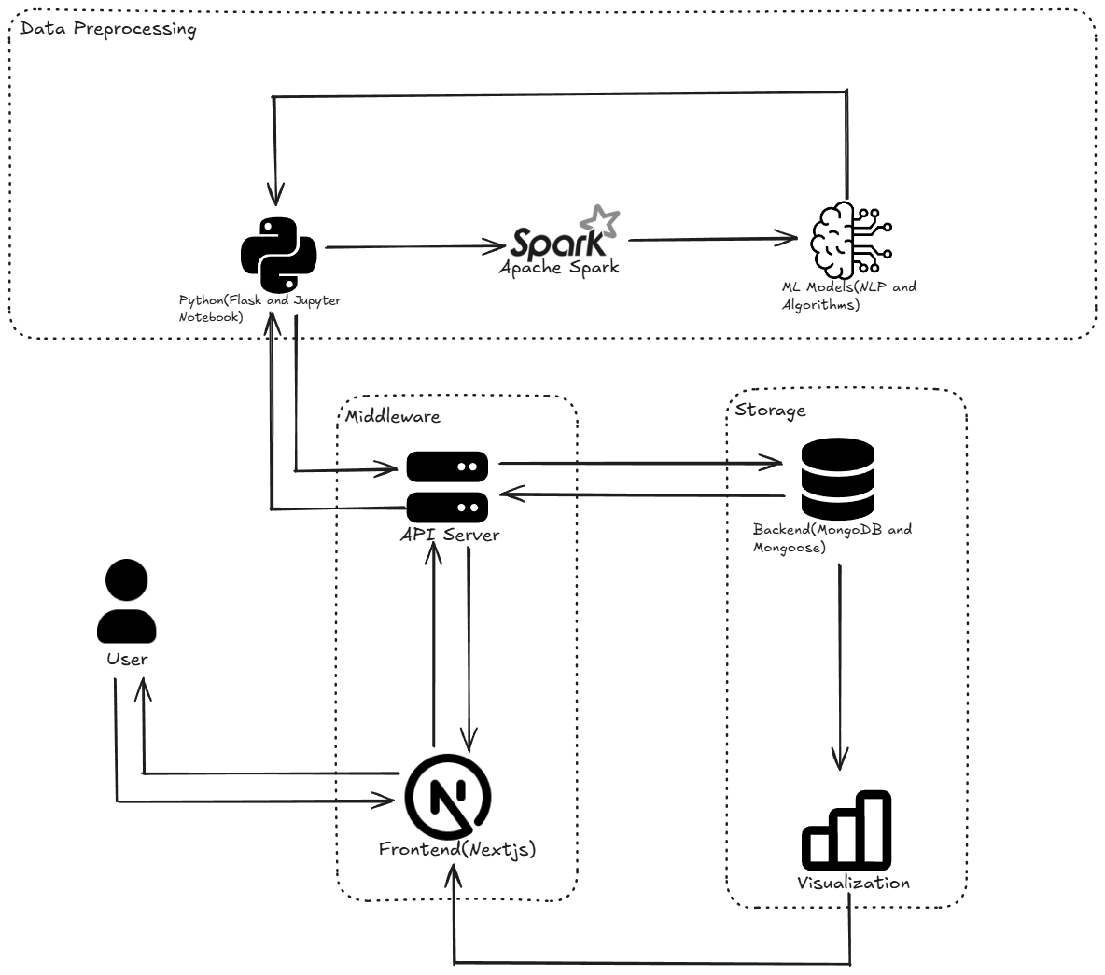

**Significance of the Project Conclusion**

This project enhances molecular research by integrating **AI-driven visualization and generation tools**, aiding drug discovery and computational chemistry. With **real-time collaboration and secure access**, it accelerates innovation in bioinformatics and scientific research.

This study showcases the effectiveness of an **AI-powered Molecular Visualization & Generation Platform** in facilitating molecular analysis and drug discovery. By integrating **RDKit.js, NVIDIA AI, and PubChem API**, the platform enables accurate **2D/3D visualization** and **SMILES-based molecule generation**. Secure authentication and real-time collaboration enhance user experience. Future work will focus on improving AI-driven predictions, expanding molecular datasets, and optimizing real-time interactions to further support research in computational chemistry and bioinformatics.

**Conference/Journal Publication Details (Mandatory)**

Annals of R.S.C.B., ISSN:1583-6258, Vol. 25, Issue 6, 2023